**USER INTERFACE DESIGN**

**<MODIFY ACCOUNT>**

1. **UI DESCRIPTION AND RELATED REQUIREMENTS**

The MODIFY ACCOUNT user interface design purpose is to handle the process for when the user is modifying their account system.

This UI satisfies the following Requirements:

* REQ #3.0

1. **UI SCREENSHOT**

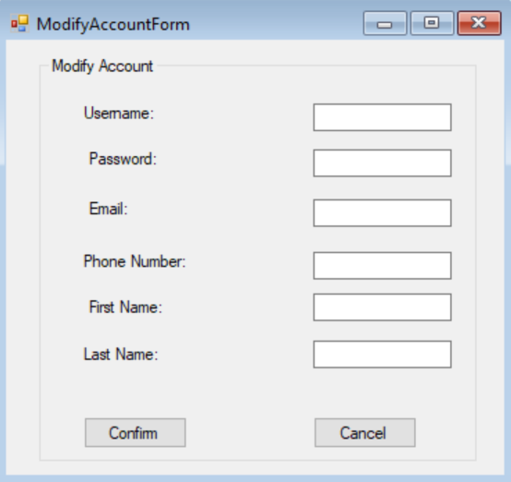

1. **UI DETAILED DESCRIPTION**

|  |  |  |
| --- | --- | --- |
| Field Name | Type | Purpose and/or Action(s) to Perform |
| userName | textbox | Displays current username until edited. Holds the new username. Max size = 20. Min size = 8. |
| userPWD | textbox | Displays current password (not visible) until edited. Holds the new password. Min size = 8. |
| firstName | textbox | Displays current first name until edited. Holds the new first name. Max size = 20. |
| lastName | textbox | Displays current last name until edited. Holds the new last name. Max size = 20. |
| emailAddress | textbox | Displays current email address until edited. Holds the new email address. Max size = 50. |
| phoneNumber | textbox | Displays current phone number until edited. Holds the new phone number. Min size = 7. Max size = 10. |
| confirm | button | triggers storing of data in edited text boxes to update user information. |
| cancel | button | closes form. |
|  |  |  |
|  |  |  |
|  |  |  |
|  |  |  |
|  |  |  |
|  |  |  |